Mulberry Park Management Company Ltd
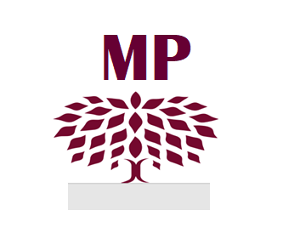
Registered Office: 2 Oak Tree Avenue, Auckley, Doncaster DN9 3HB
Company Registration Number: 3132875
Email: mulberryparkauckley@gmail.com

Testimonial for Joey Perkins November 2025

I have the pleasure of providing the following testimonial for Joey Perkins on behalf of the Mulberry Park Management Company Ltd (a small private Estate Management Company):

Joey has significantly supported the Mulberry Park Management Company Ltd, particularly over the past 4 years. He demonstrates an open and most amiable character and has an inquisitive personality which he applies diligently in engaging with our company establishment and its operational needs.

Joey has provided outstanding IT development and administrative support services for the company and has proved to be a most competent, exceptional and accomplished IT Technician. He has set up, configured and backed up our laptops, data, mobile phones, printers/scanners and ancillary equipment for the company and he demonstrates valuable skills and knowledge in respect of our systems setup for networking, backup, cyber security, and CCTV installations, he also has skills in 3-D printing and laser engraving.

Joeys knowledge of MS Office applications and of other bespoke software such as financial and administrative programs is considerable and he is able to configure and adapt applications to meet the challenging and varying demands of the company.

Joey has recently set up a unique domain website for the company, providing links to information and proforma documents aimed at engaging with our customers at a level reflective of their particular needs and understanding.

On an administrative front, Joey has supported the company in various ways through the checking of database platform information relating to core company accounts. This provides the valid financial status and customer accounting information required by the company to be produced and subsequently mailed out digitally or hand delivered to our clients. In respect of hand delivered mail, Joey provides a date and time-stamped photographic or video record as proof of delivery for such mail, which is often of a commercially sensitive nature relating to important and time correlated financial transactions or essential company meeting engagements.

In addition, Joey is involved in the company estate site inspections and he provides the company with photographic records of infrastructure defects, condition evaluations and site maintenance requirements and recommendations.

Recommendation

Joey is a well-balanced, considerate and highly intelligent individual who is meticulous, methodical and dedicated in all he does and achieves. I have great confidence in Joey’s technical abilities and no hesitation in endorsing Joey’s admirable work ethics and service delivery practices, and in particular those relating to his exceptional IT knowledge and skills in support of his future aspirations and direction to provide freelance business services in technical support and networking.

I wish Joey well in his future vocational endeavours and look forward to progressing his technical support provisions for the company.

Sincerely

Barry Roughley BSc (Hons), MCIHT, MJF
Director – Mulberry Park Management Company Ltd

